Name: Cedric Commey

Index N0: 9341717

Design Architecture for School Management System

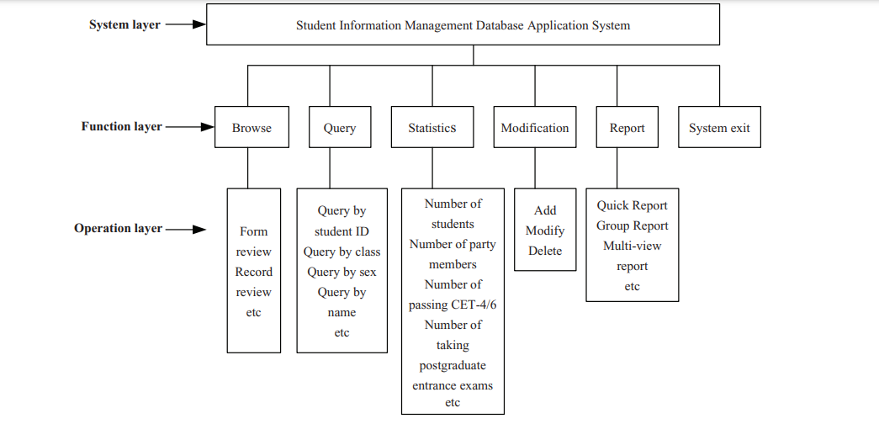

Microservice architecture – a variant of the service-oriented architecture (SOA) structural style – arranges an application as a collection of loosely-coupled services. In a microservices architecture, services are fine-grained and the protocols are lightweight.

The benefit of Using Microservices Approach

* Modularity: This makes the application easier to understand, develop, test, and become more resilient to architecture erosion.[5] This benefit is often argued in comparison to the complexity of monolithic architectures.[28]
* Scalability: Since microservices are implemented and deployed independently of each other, i.e. they run within independent processes, they can be monitored and scaled independently.[29]
* Integration of heterogeneous and legacy systems: microservices is considered as a viable means for modernizing existing monolithic software application.[30][31] There are experience reports of several companies who have successfully replaced (parts of) their existing software by microservices, or are in the process of doing so.[32] The process for Software modernization of legacy applications is done using an incremental approach.[33]
* Distributed development: it parallelizes development by enabling small autonomous teams to develop, deploy and scale their respective services independently.[34] It also allows the architecture of an individual service to emerge through continuous refactoring.[35] Microservice-based architectures facilitate continuous integration, continuous delivery and deployment.[36]

Criticism For Microservices Approach

* Services form information barriers.
* Inter-service calls over a network have a higher cost in terms of network latency and message processing time than in-process calls within a monolithic service process.
* Testing and deployment are more complicated.